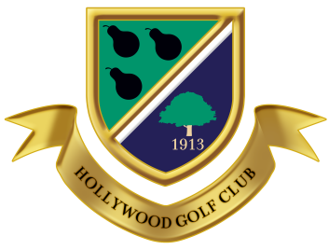
HOLLYWOOD GOLF CLUB LTD
Hollywood Lane, Hollywood, Birmingham, B47 5PP
Tel: 0121 430 8544 option 1

THE MEN’S PAIRS OPEN - ENTRY FORM

Saturday 4th July 2020
18 Hole Medal Play, 4 Ball Betterball – 90% Handicap Allowance. Maximum Handicap 24
Prizes: Best Gross Score and nett Prizes

Members - £20.00 per pair Visitors - £40.00 per pair

Name ………………………………………………….. Tel No ………………………….

Address ……………………………………………………………………………………...

Club ……………………………………………………. Age …….….. Handicap …..……

E Mail (PLEASE PRINT CLEARLY)…………………………………………………………………

Partners Name ………………………………………… Tel No ………………………….

Address ……………………………………………………………………………………...

Club ……………………………………………………. Age …………Handicap .………

Preferred Start Time (not guaranteed) …………. Early entries will receive priority

Signed ………………………………………….. Date …………………………………….

Payment can be made by cheque payable to Hollywood Golf Club Ltd or by debit card by telephoning the Secretary on 0121 430 8544 option 1.

-------------------------------------------------------------------------------------------------------------------------------
Hollywood Golf Club Ltd – The Men’s Pairs Open –
Saturday 4th July 2020

Name ………………………………………………………………………………………..

Tee Allocated …………………………………… Fee Received ………………………

Signed …………………………………………….. Date ………………………………..

A valid CONGU Handicap certificate must be produced prior to play on the day
Entry forms may also be downloaded from our website: www.hollywoodgolfclub.co.uk or Email: secretary@hollywoodgolfclub.co.uk
Please observe the Dress Code at all times
Prize winners will be expected to attend the presentation

